WE NEED SKATEBOARDERS FOR OUR MUSIC VIDEO
IF YOU CAN SKATE (REALLY SKATE) AND YOU WANT TO BE IN A MUSIC VIDEO FOR ONE OF THE HOTTEST UP-AND-COMERS IN THE RAP GAME CONTACT US IMMEDIATELY!!!

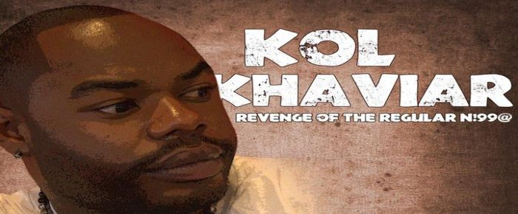

WHEN: THIS SUNDAY APRIL 8th (EASTER DAY) AROUND NOON
WHERE: ASU TEMPE CAMPUS
DURATION: 2 HOURS
WHY: To promote KOL KHAVIAR’s latest mixtape REVENGE OF THE REGULAR N!99@
TRACK: “THEY DON’T GIVE A F*CK ABOUT ME”
IF YOU ARE INTERESTED PLEASE CONTACT GRANT DAVID IMMEDIATELY!!! ALL HELP IS VERY MUCH APPRECIATED. HOPE TO SEE YOU THERE.
GRANT DAVID (DIRECTOR) –
- 360-601-5410 (cell, call or text)
- gmdavid@asu.edu
- facebook.com/GDsoFRESH
- @GDsoFRESH

SEARCH: “KOL KHAVIAR” ON YOUTUBE TO SEE ALL OF HIS MUSIC VIDEOS
SEARCH: “KOL KHAVIAR” ON SOUNDCLOUD TO HEAR THE ENTIRE REVENGE OF THE REGULAR N!99@ MIXTAPE FOR FREE

